Manchester United Monthly Tweet Count

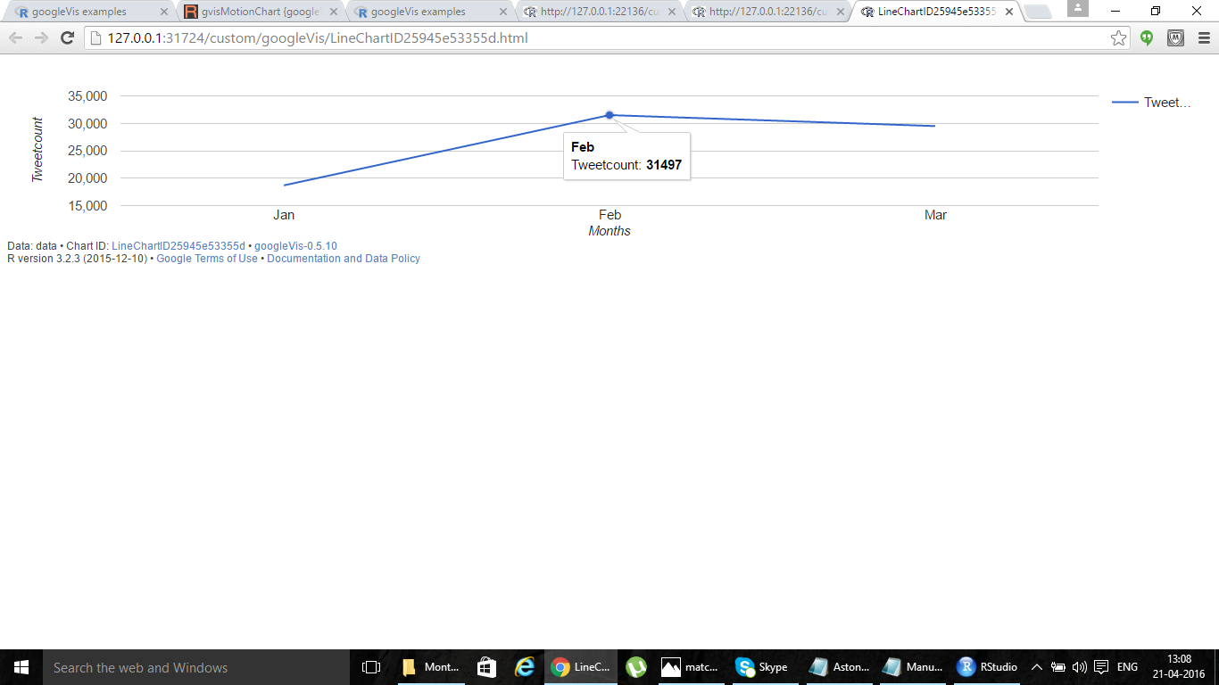

Gameweek 32 Match Popularity

